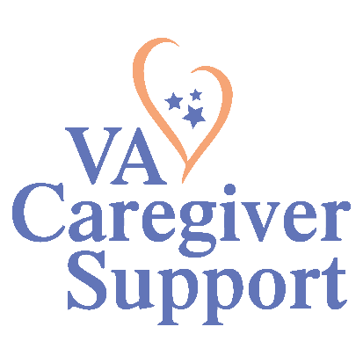

Hello!

On behalf of The Kansas City VA Medical Center I would like to invite you to participate in our Caregiver Support Program: Caregiver & Family Resource Fair.

The Department of Veterans Affairs (VHA) Caregiver Support Program (CSP) provides support and services for caregivers of Veterans. The mission of the CSP is to promote the health and well-being of caregivers who care for our nation’s Veterans. Our focus is to improve the quality of life of caregivers. This, in turn, assists them in helping Veterans live to their fullest potential. We accomplish this by providing support, helping caregivers navigate the VA health care system and access resources.

Our trusted partnerships demonstrate our ongoing commitment to service excellence. We invite you to host a resource table showcase your support of caregivers and resources you provide.

The Caregiver Support Program Caregiver & Family Resource Fair will be held from 9am-12pm on Tuesday April 30th, 2024 at the Kansas City VA Medical Center in the Hall of Heroes. Registration and set up will begin at 8:30am and take down will happen from 12p-12:30p.

Kansas City VA Medical Center: 4801 E. Linwood Blvd Kansas City, MO 64108

Please RSVP to Rebecca Stigler at Rebecca.Stigler@VA.gov with the name of your representative by [4/19/2024].

If you have any questions or suggestions, please feel free to contact General Caregiver Support Program Coordinator Lanisha Harrell by phone or email 816-377-0168 or Lanisha.Harrell@VA.gov

If you wish to attend, please complete the Exhibitor form by [4/19/2024].

Thank you for your interest.

Respectfully,

The Kansas City Caregiver Support Program

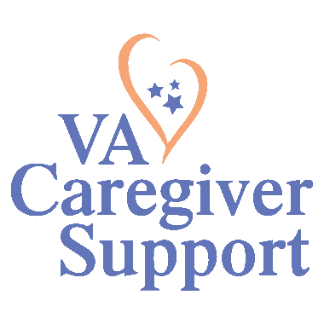
EXHIBITOR INFORMATION FORM
Caregiver & Family Resource Fair

Date: 4/30/2024
Location: Kansas City VA Medical Center-
4801 E. Linwood Blvd Kansas City, MO 64108
Hall of Heroes
(set up: 8:30 am-9am--take down: 12 pm-12:30 pm)

Exhibitor Name/Title:
Co-exhibitor names/titles (if applicable):

Exhibitor Agency/Organization:

Address:
City/State/Zip: Work Phone:
Exhibitor’s E-mail Address:
Agency Phone number & Website:

Space needed (if in person) or amount of time requested for presentation (if virtual):

Please give a brief description of your exhibit/resources (100 words or less):

Would you like to attend the Virtual Caregiver Support Summit which will be held virtually on 6/28/2024:
Yes:______ No: _____
*Please have your agency’s resources available both electronically and in printed version to
provide to attendees either during or following the event.

Please return this form by 4/19/2024 to: Rebecca.Stigler@VA.gov

For any questions please contact: General Caregiver Support Program Coordinator Lanisha Harrell by phone or email 816-377-0168 or Lanisha.Harrell@VA.gov

